Test Case: tc001_SPX_Dev5_Consulta_Administracion_Accesos
Step 1 - Enter username and password and click to button Enter : Credentials Entered
Image file-name: QC_Testing-tc001_SPX_Dev5_Consulta_Administracion_Accesos-dic. 26 2025, 03 16 57 p. m.

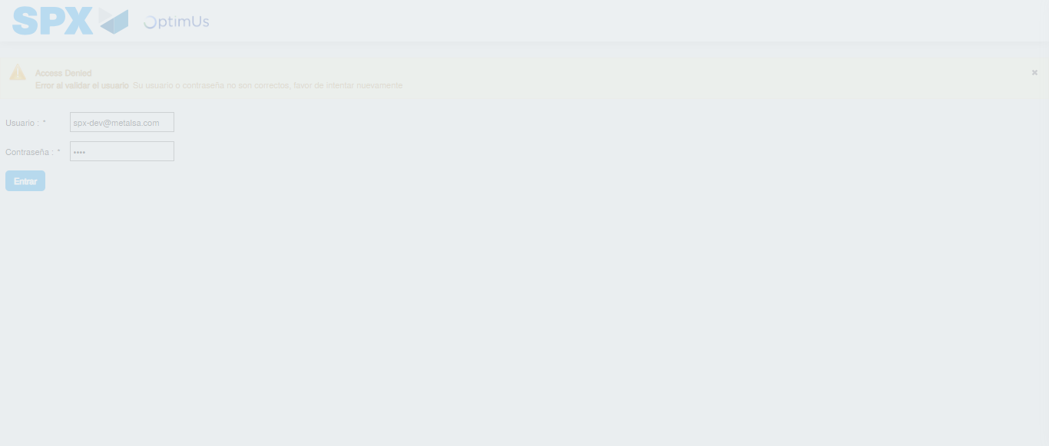Image file-name: QC_Testing-tc001_SPX_Dev5_Consulta_Administracion_Accesos-dic. 26 2025, 03 16 58 p. m.

Step 2 - Select to UEN and Access to Administraci�n de Accesos: UEN Correctly selected and Correct access
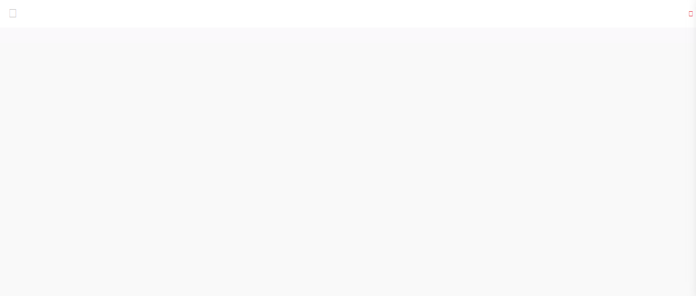Image file-name: QC_Testing-tc001_SPX_Dev5_Consulta_Administracion_Accesos-dic. 26 2025, 03 17 09 p. m.

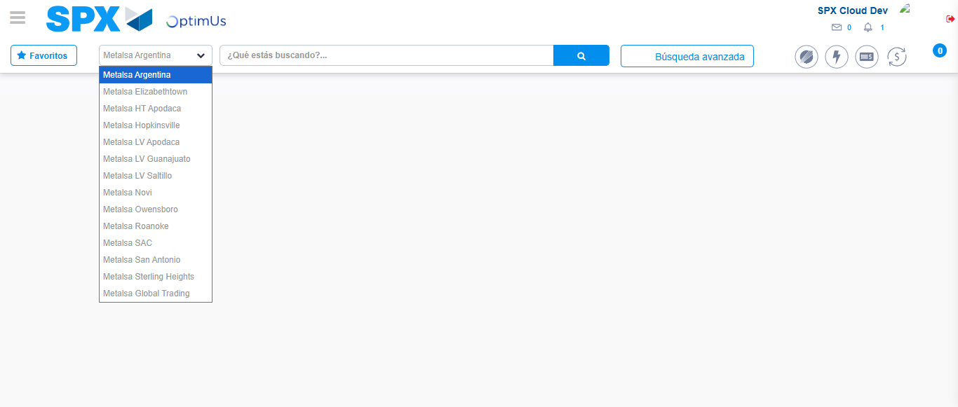Image file-name: QC_Testing-tc001_SPX_Dev5_Consulta_Administracion_Accesos-dic. 26 2025, 03 17 11 p. m.

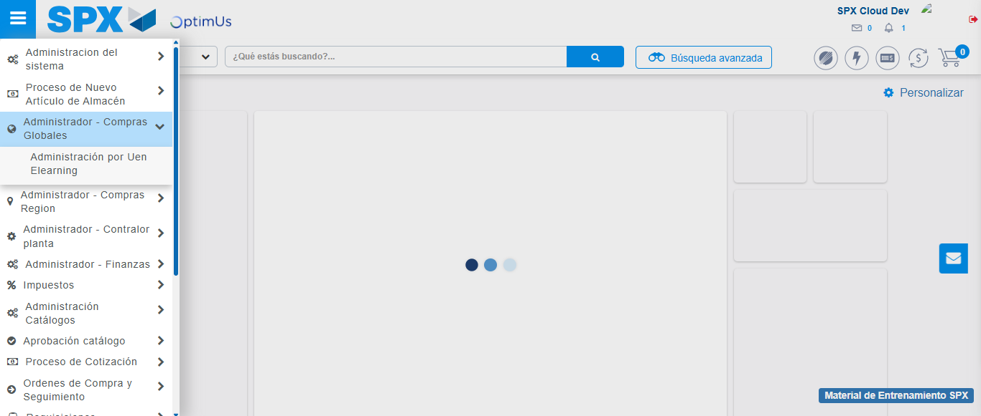Image file-name: QC_Testing-tc001_SPX_Dev5_Consulta_Administracion_Accesos-dic. 26 2025, 03 17 12 p. m.

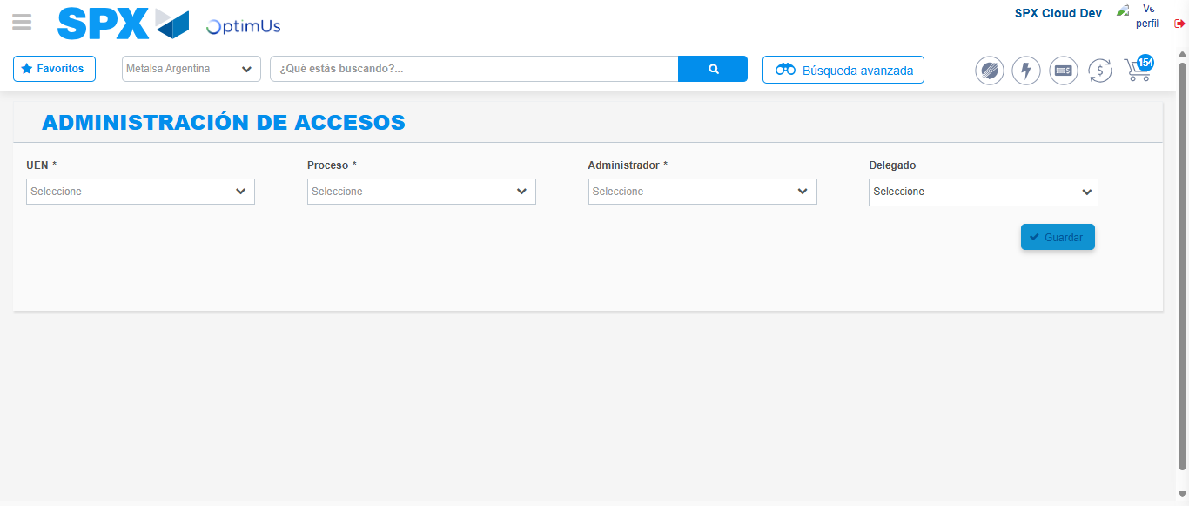Image file-name: QC_Testing-tc001_SPX_Dev5_Consulta_Administracion_Accesos-dic. 26 2025, 03 17 17 p. m.

Step 3 - Review information on Aprobaci�n Catalogos: Correct Data
Image file-name: QC_Testing-tc001_SPX_Dev5_Consulta_Administracion_Accesos-dic. 26 2025, 03 17 17 p. m.

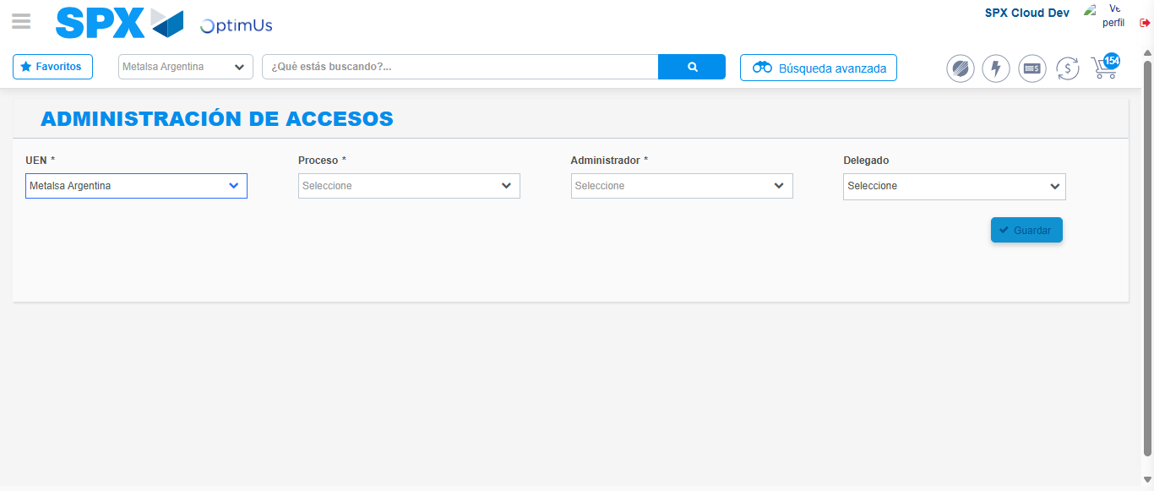Image file-name: QC_Testing-tc001_SPX_Dev5_Consulta_Administracion_Accesos-dic. 26 2025, 03 17 18 p. m.

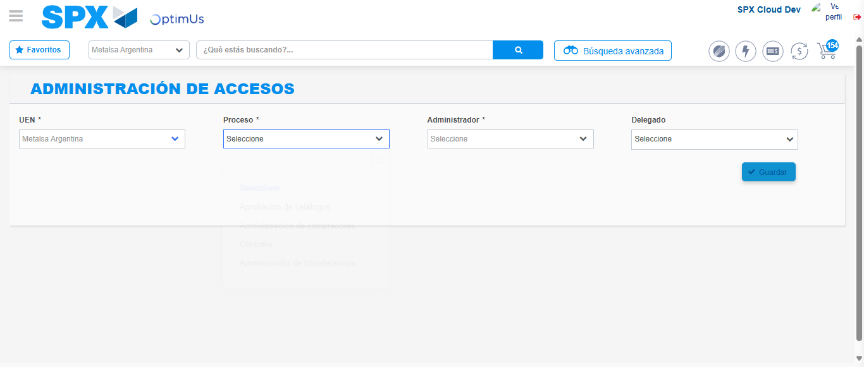Image file-name: QC_Testing-tc001_SPX_Dev5_Consulta_Administracion_Accesos-dic. 26 2025, 03 17 19 p. m.

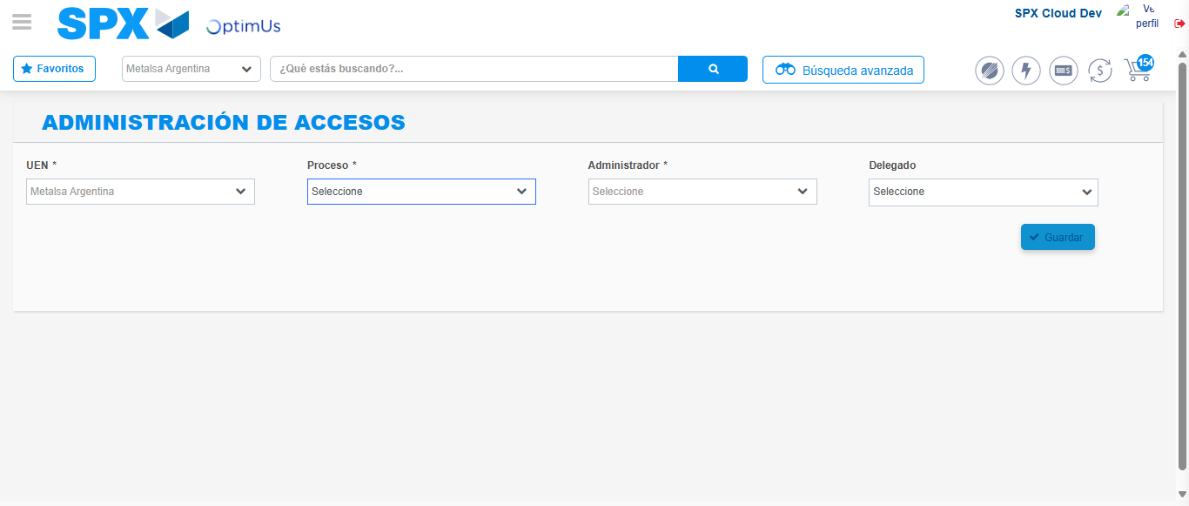Image file-name: QC_Testing-tc001_SPX_Dev5_Consulta_Administracion_Accesos-dic. 26 2025, 03 17 45 p. m.

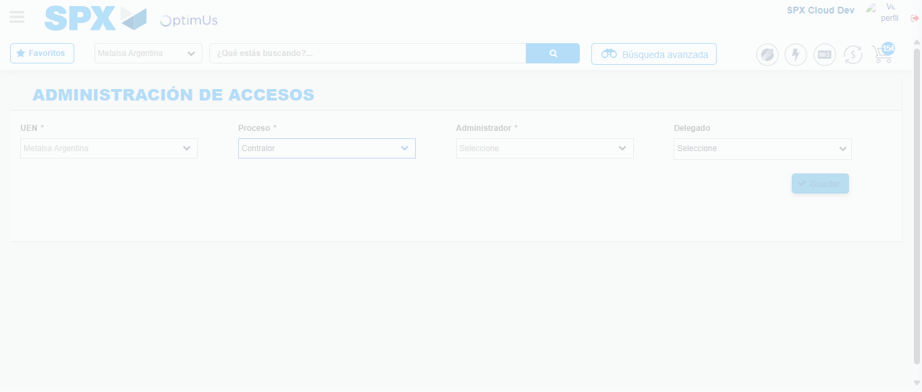Image file-name: QC_Testing-tc001_SPX_Dev5_Consulta_Administracion_Accesos-dic. 26 2025, 03 18 10 p. m.

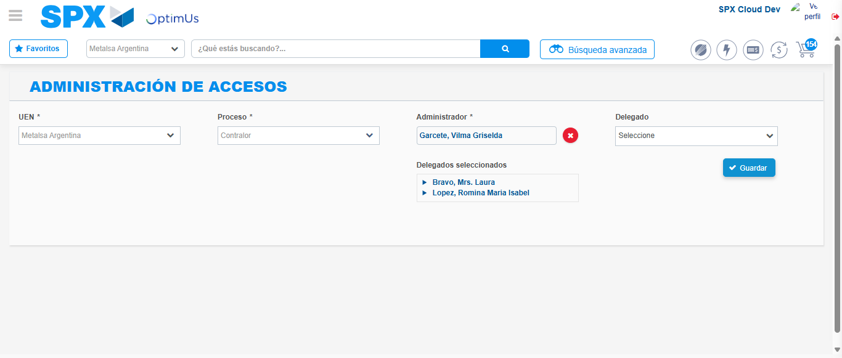Image file-name: QC_Testing-tc001_SPX_Dev5_Consulta_Administracion_Accesos-dic. 26 2025, 03 18 27 p. m.

